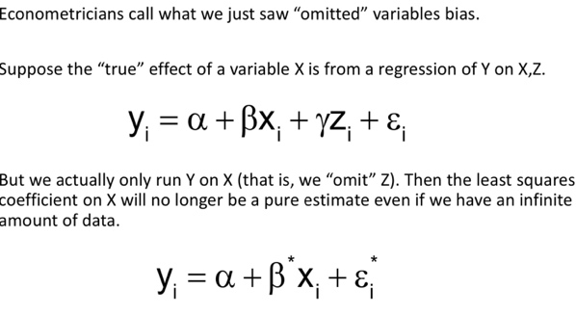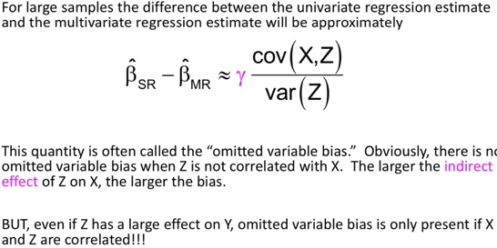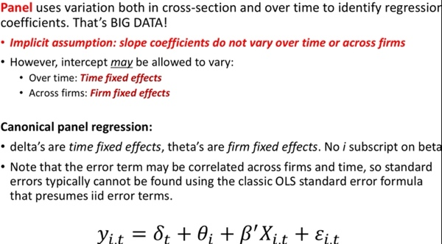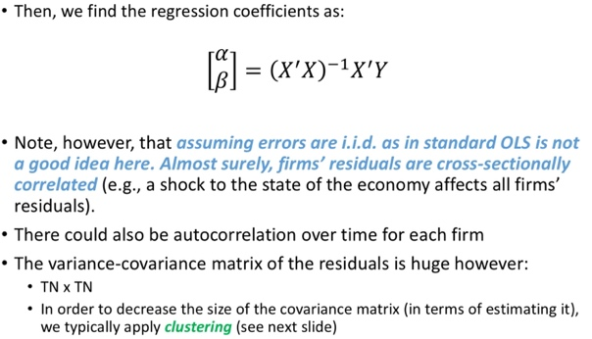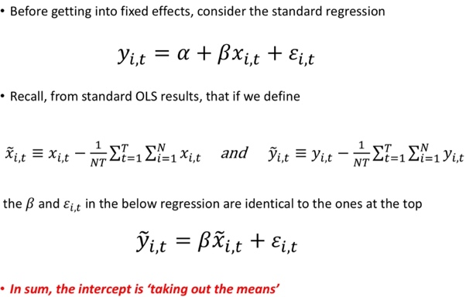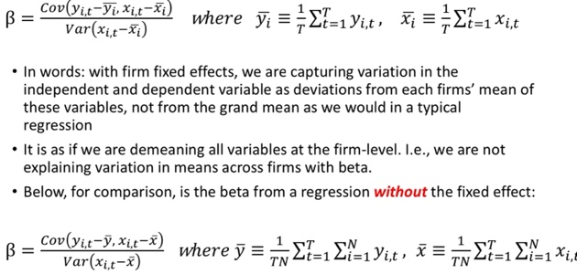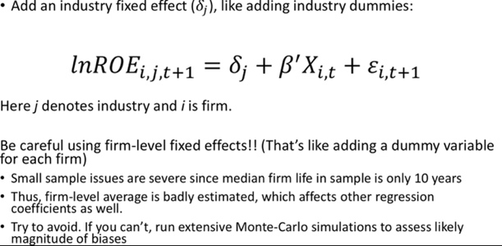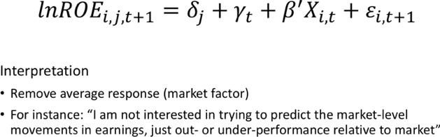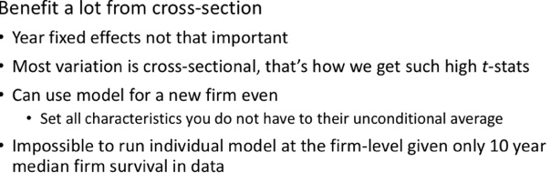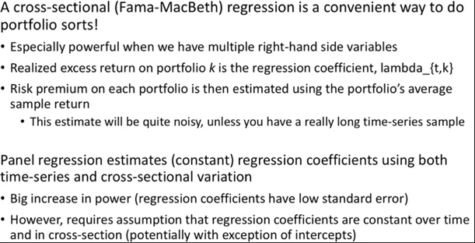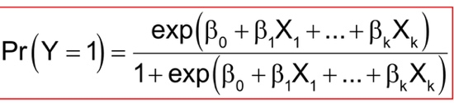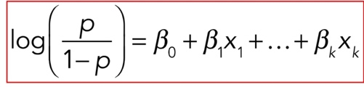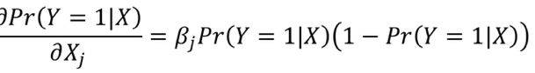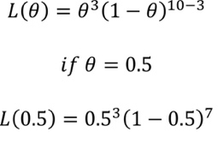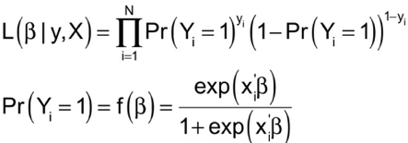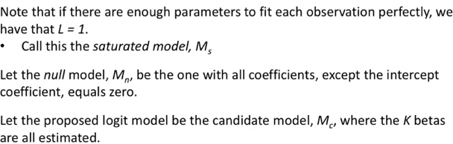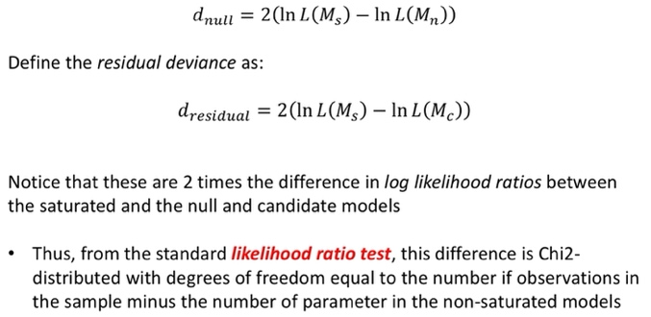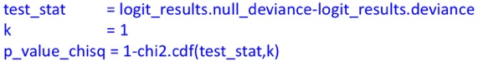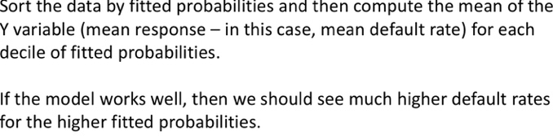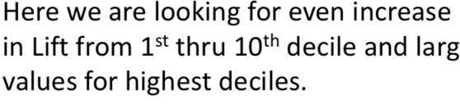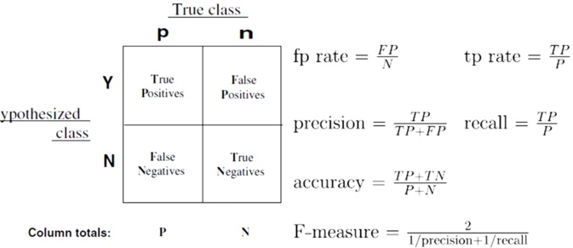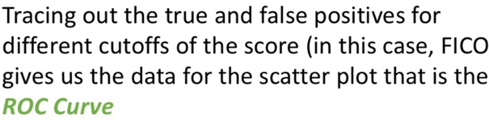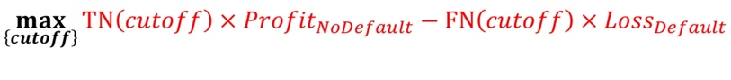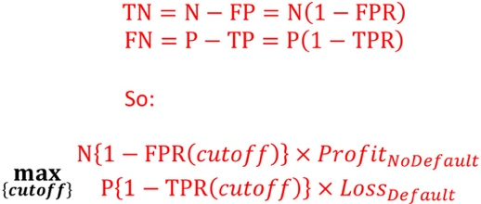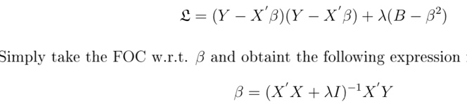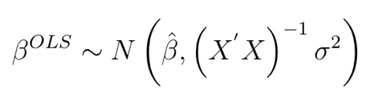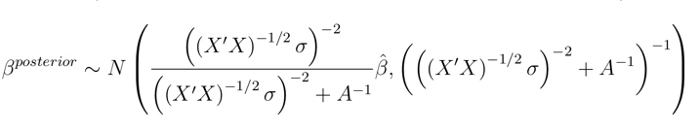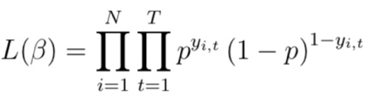

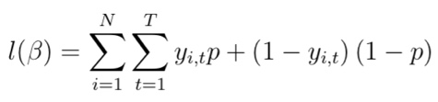

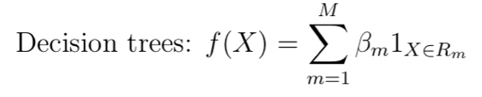

The objective function is then to find the set of boxes that minimizes the sum of squared errors(SSE): 

In particular, a random selection of m of the p predictors are chosen for each bootstrapped sample. This reduces correlation due to less overlap

Bagging involved overfitting of each individual tree, but then averaging to get rid of noise in samples with low correlation, Boosting fits smaller trees and instead learns slowly by sequentially adding small trees fit to the prediction errors of the existing ‘ensemble’ of trees. Thus, each tree added depends on the trees already grown

XGBoost

A regularization term defines tree complexity as:

